XPOL Radar Setup

NOTE: Before we can do the XPOL radar setup, we need to remember to get a 5/16” hex wrench for the bolts that attach the cradle to the trailer.

NOTE: Bring a computer monitor with you to hook up to the computers in the trailer to make sure they boot properly. A keyboard and mouse are stored in the trailer so do not need to be brought along.

(I apologize if my terminology is wrong throughout this document. I don’t know what the parts of the radar are called so I’ll describe things as best I can and we can fix the names later.)

Here is what the radar looks like when it is on the trailer ready for traveling:

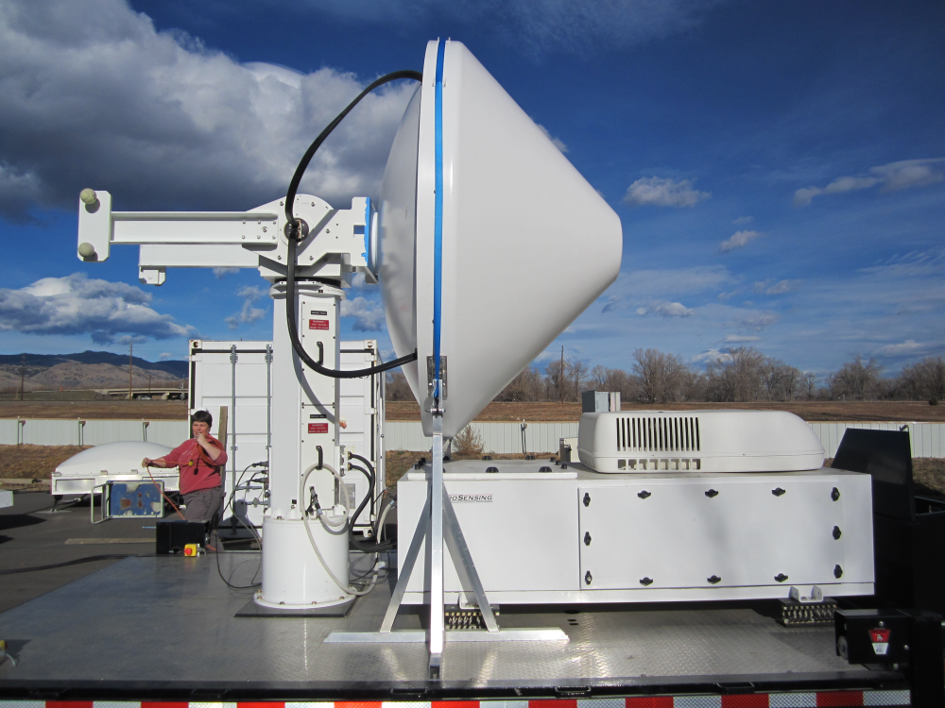

Computer housing

Cradle

Upper Pedestal controls

Lower Pedestal controls

When setting up the radar, you should first position the trailer so that it points in an ordinal direction (north, south, east or west) if possible. This makes the radar configuration easier.

# Installing the Brake Release

Before beginning, make sure that the toggle switches on the lower pedestal controls are set to “Safe” and “OFF” as in the following picture:

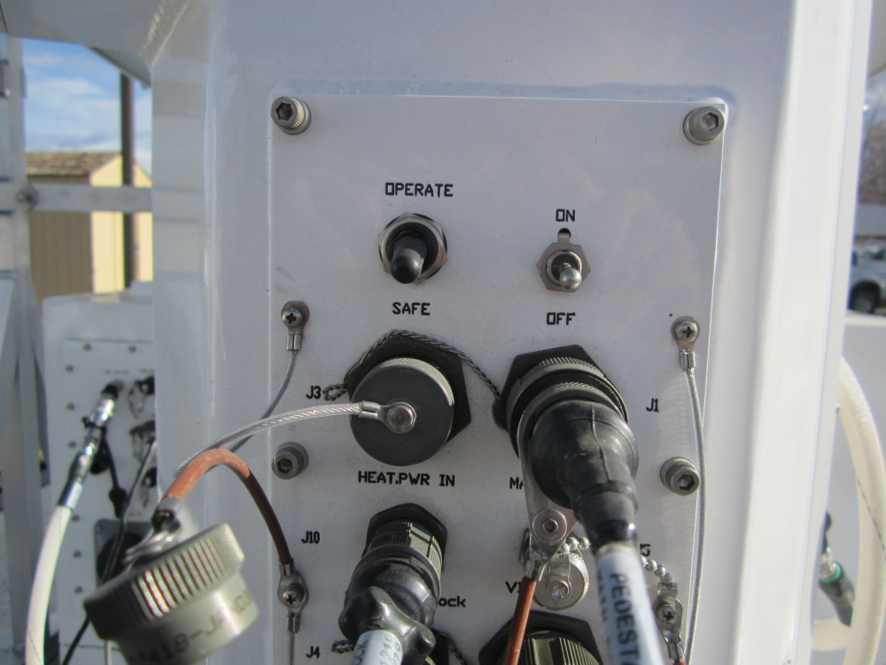

Switches off

You can then install the brake release device. This device is stored in a white plastic bag in the compartment at the front of the trailer. First connect the power brake cables to the pedestal. The “az” brake cable goes in the “control” connection in the lower pedestal controls. The “el” brake cable goes in the “j8 service” connection in the upper pedestal controls. This picture shows the upper pedestal controls with the “el” brake release cable connected.

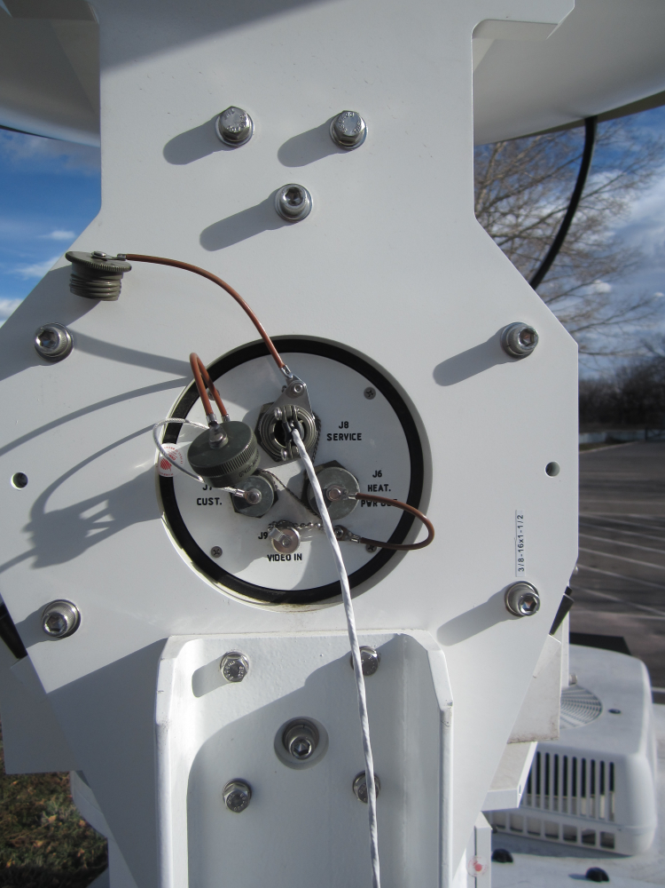

Elevation brake cable

And this picture shows the lower pedestal controls with the “az” brake release cable connected.

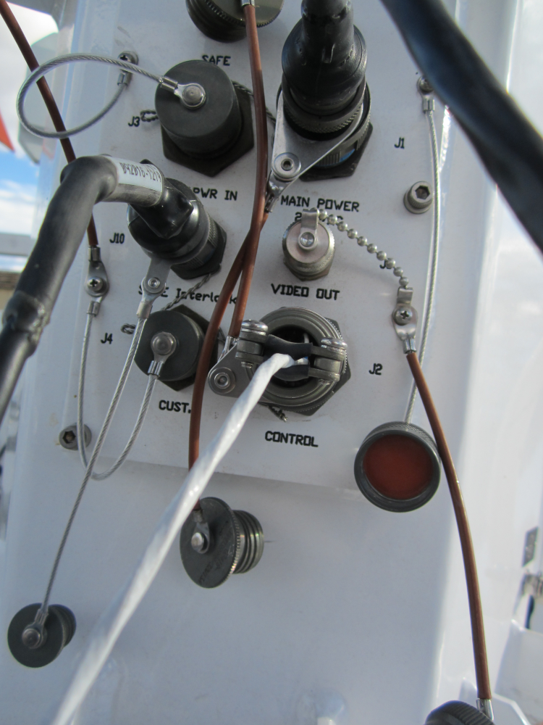

Azimuth brake cable

Once the cables are connected to the pedestal, connect the brake release device to power and turn it on. You should hear a click when it comes on and releases the brake.

Remove the blue strap from around the radar. Lift the radar out of the cradle and put it in an upright position. Now you can turn off the brake release device and remove it from the pedestal. Replace the cap on the “j8 service” connector in the upper pedestal controls and put the “antenna control” cable in the “control” connector in the lower pedestal controls.

# Removing the Cradle

At this point you can remove the cradle from the trailer. The cradle is attached to the trailer with 3 bolts on each side.

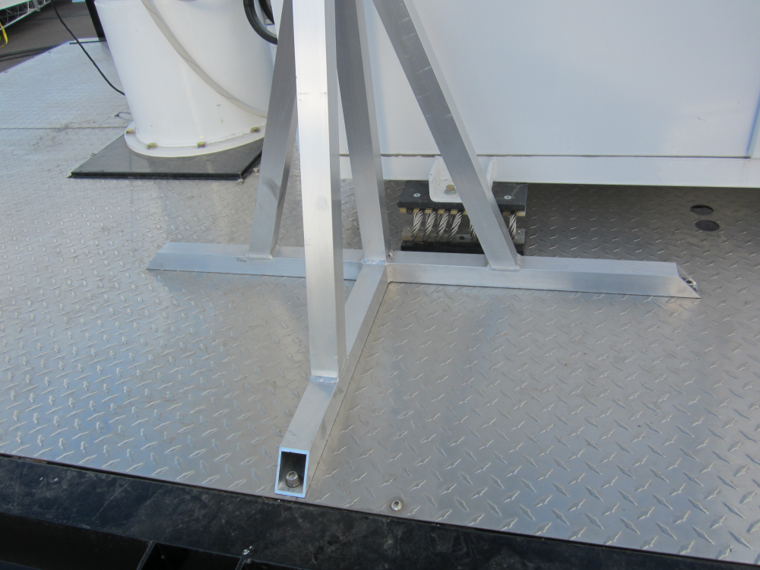

Bolts

Remove the bolts, remove the cradle, then replace the bolts in the trailer. This is where you need the 5/16” hex wrench.

# Hooking up Cables

All of the cables are stored in the cubby at the front of the trailer. You will need to pull out the power and Ethernet cables as well as the GPS. They are all connected into the main panel pictured below:

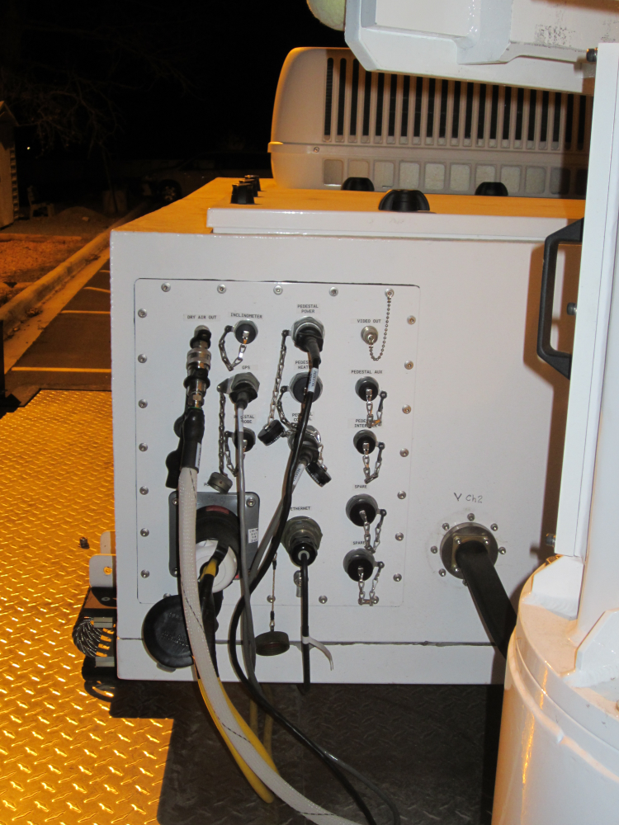

GPS

Ethernet

Power

The main panel is located at the back of the computer housing.

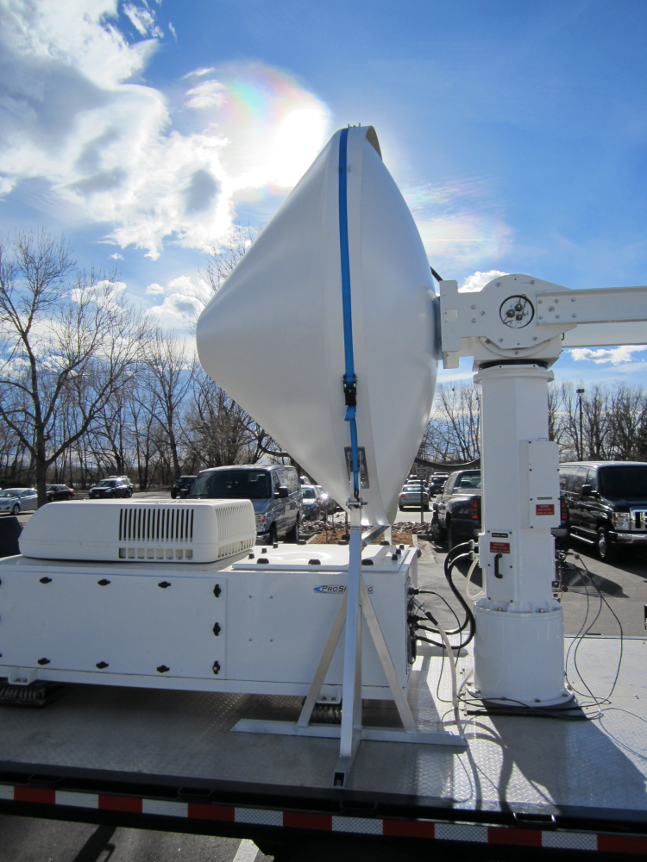

Main panel

The GPS should be put on the post at the front of the trailer as shown in the next picture. The cable can run underneath the computer housing.

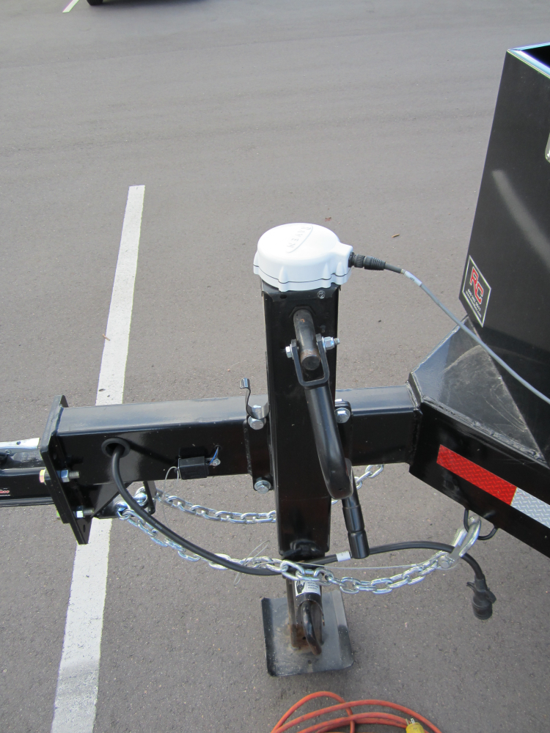

# Turning on the Computers

The computers are stored in the computer housing in front of the radar. The panel in the following picture gives access to the UPSs and the fronts of the computers:



Access to UPSs and fronts of computers

Here is a picture with the cover removed:

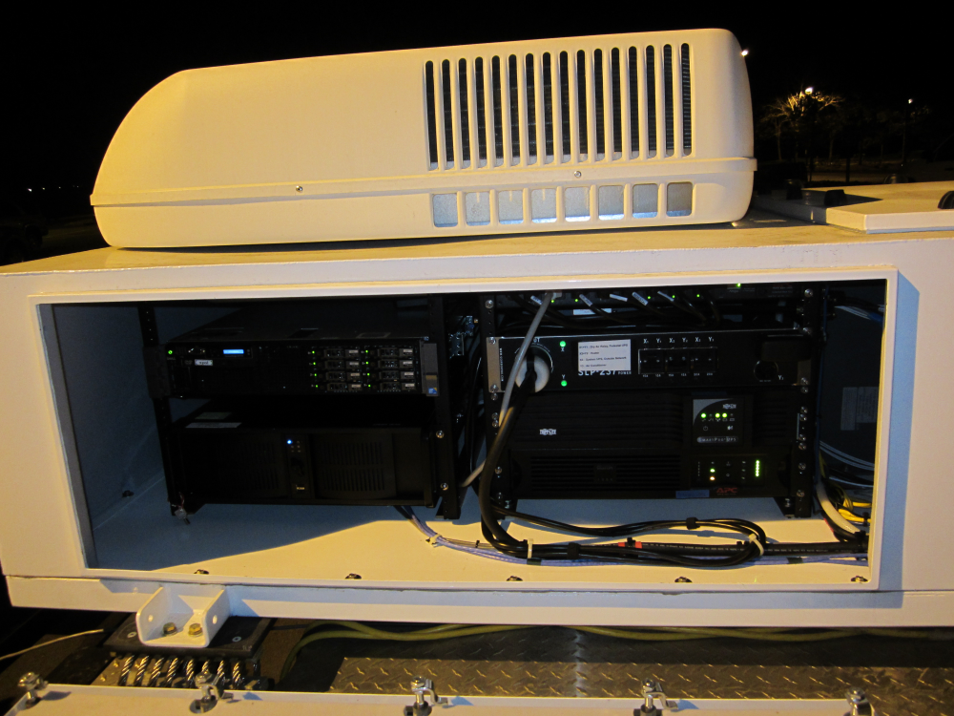

Heater (inside)

Breakers

UPSs

drx

xpol

First, switch on the breakers. We won’t be using the heater unless it gets really cold, so leave the heater breakers (X2/Y2) off. The heater will be covered below. Here is a picture of what the breakers should look like at this point (it’s hard to see, but X1/Y1 and X3/Y3 are on while X2/Y2 are off):

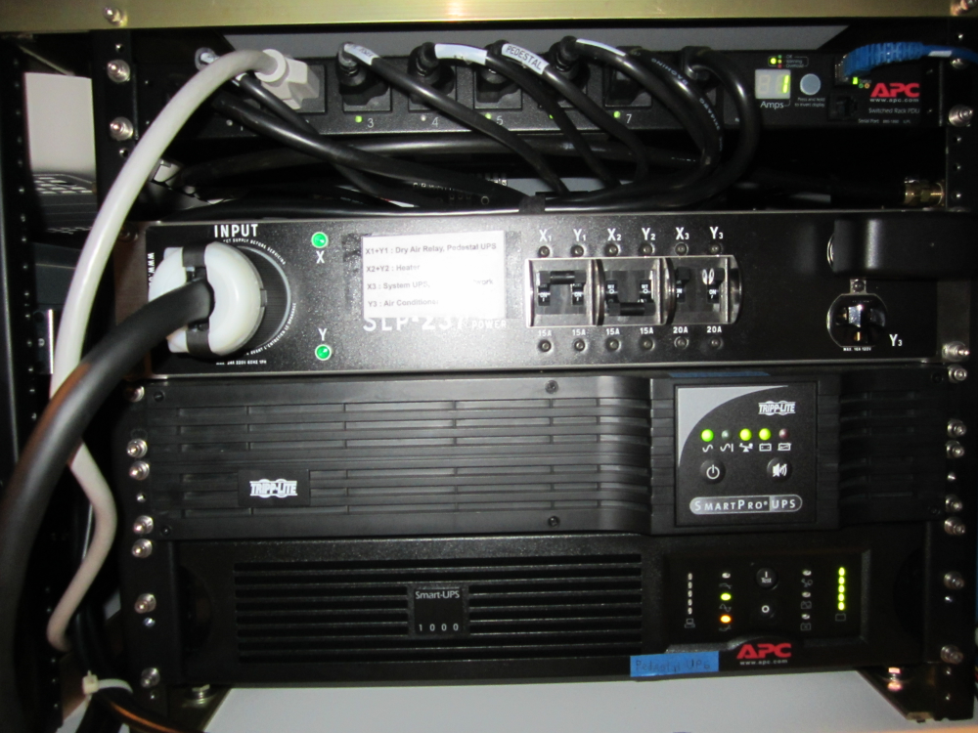

off

on

Next, turn on the UPSs. You will need to push on the power button for each UPS for a little while until it starts up. For the lower UPS, you may need to use the back of a pencil as the button is recessed.

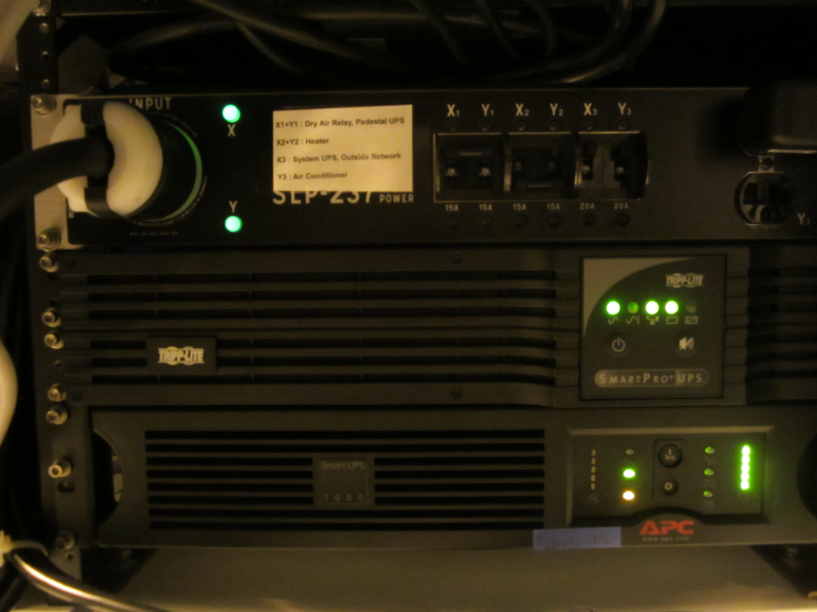

On buttons

The computers should start up automatically when you turn on the UPS. You should hear the computer fans come on loud at first, but then quiet down after the computers boot up.

The panel on the opposite side of the housing gives access to the backs of the computers. This panel should be removed and a computer monitor should be attached to monitor the boot status of the computers. A keyboard and mouse are stored in this area in case they are needed and there is a power strip there for the monitor. Here is a picture of this area with the monitor, mouse and keyboard attached.

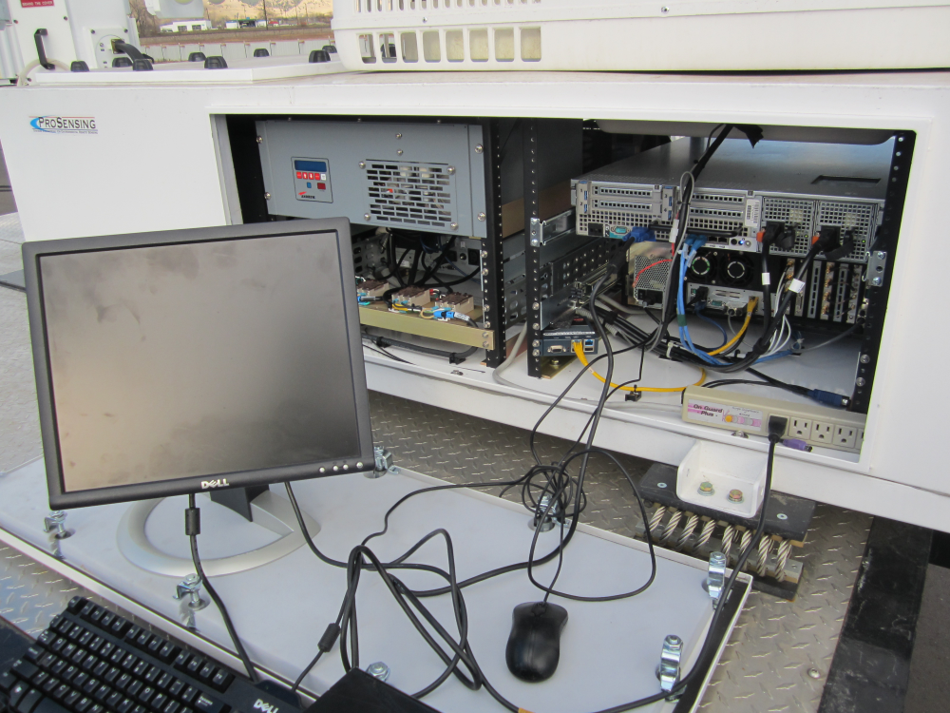

drx

xpol

Finally, make sure that the pedestal is switched back on:

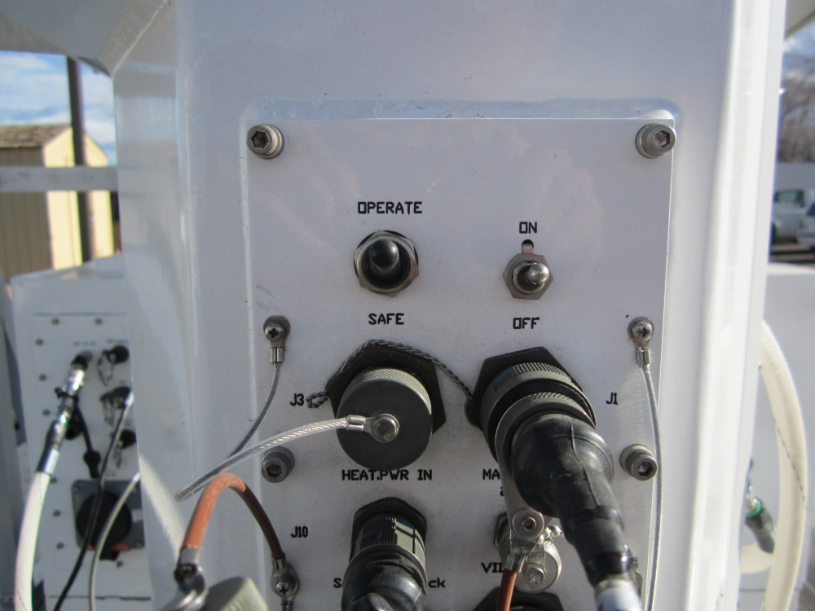

Switches on

At this point, the radar should be ready to go.

# Transmitter

The transmitter is stored in the computer housing on the side next to the radar. It is accessed through a panel on the top of the housing. If the radar does not seem to be transmitting, check the transmitter.

For safety reasons, you must switch off the pedestal before accessing the transmitter. To do this, switch the toggles on the lower pedestal controls to “SAFE” and “OFF” as shown in the following picture:

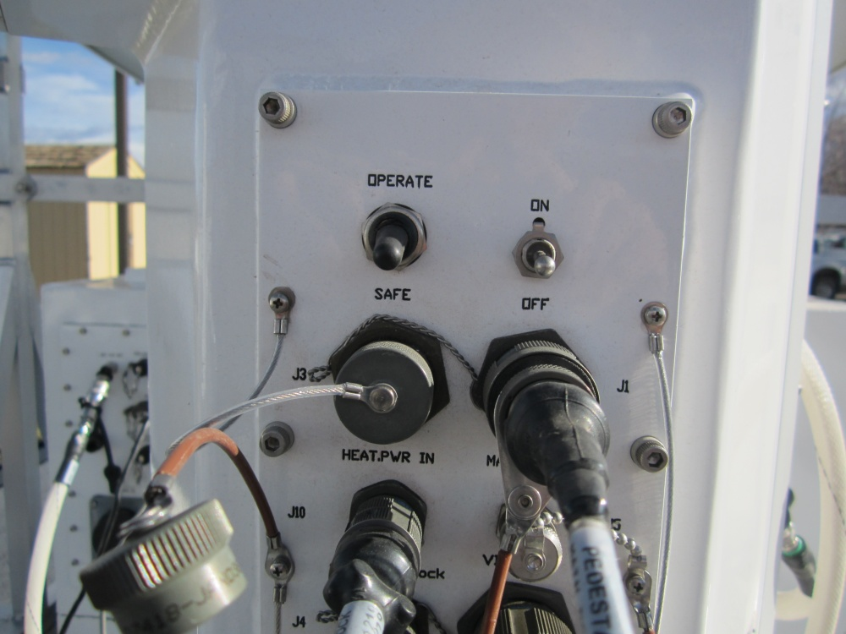

toggles

You can then remove the cover for the transmitter access.

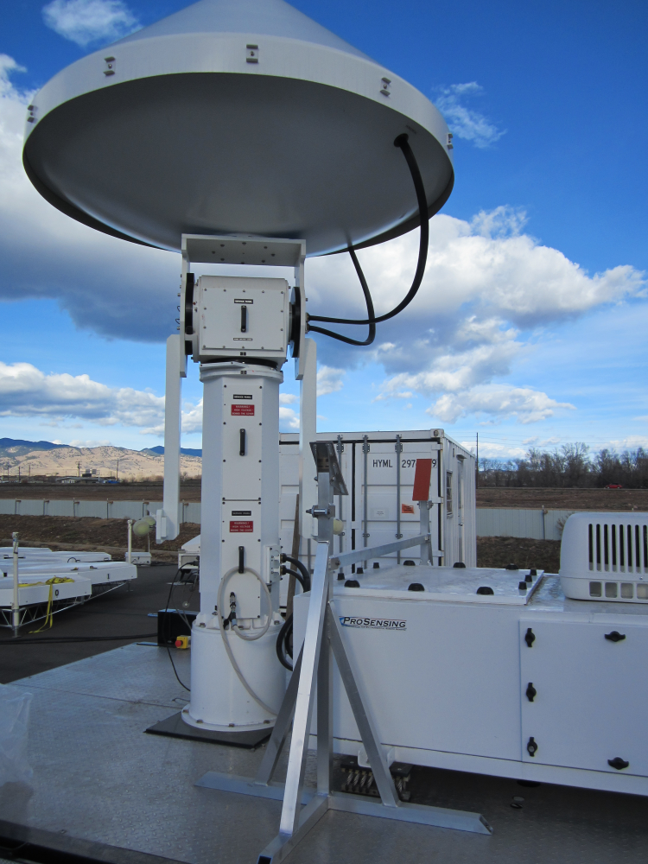

Transmitter access cover

When you open the cover, you’ll see the transmitter. It has a cover which can be removed to access some switches:

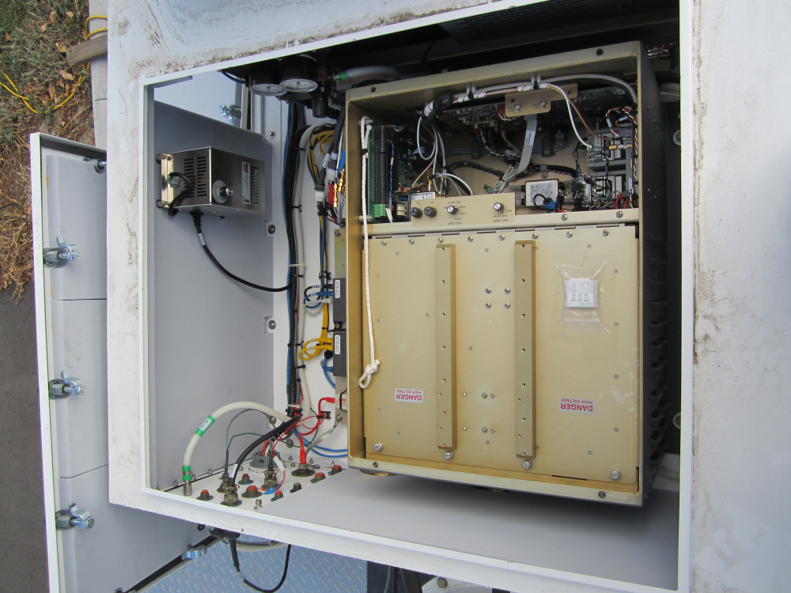

Transmitter with cover removed

On the top, you’ll see some switches. In order to transmit, the transmitter must be set to “TX ON” as shown below. When packing up the radar, we left it pointing to “TX ON”, so it should already be in the proper state.

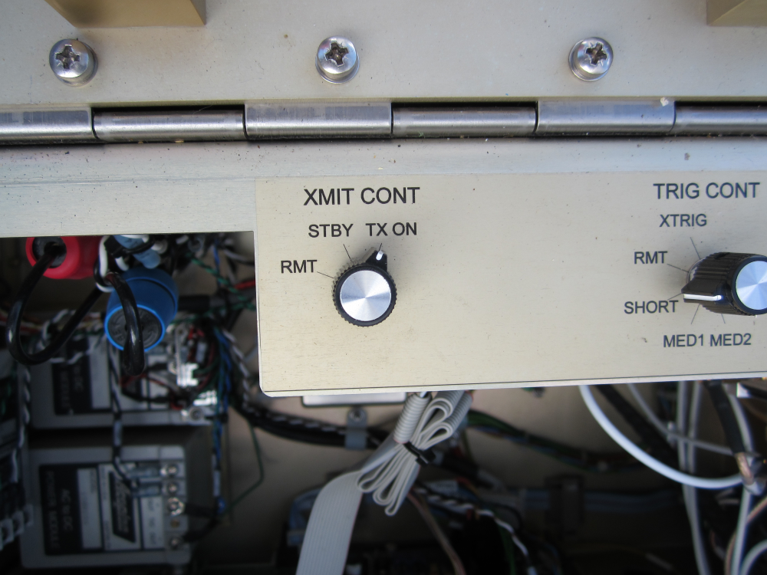

Remember to turn the pedestal back on when you are finished accessing the transmitter area.

When you are looking at the transmitter, you may notice a couple of pressure gauges in the same area:

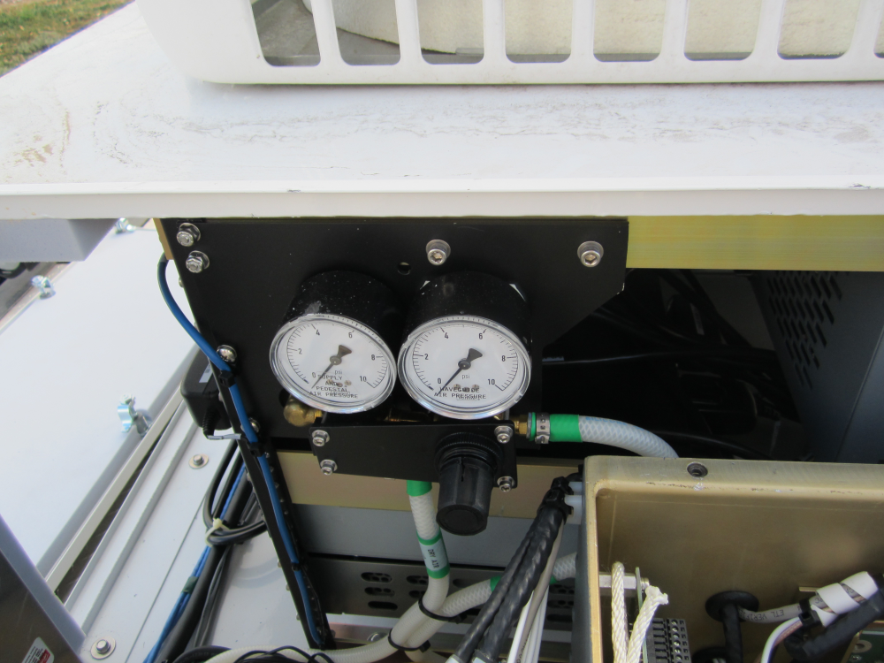

It may seem concerning that the gauges always measure 0 or below, but that is expected. This is not a pressurized system and we’re not sure why the gauges are there.

# Heater

The heater is stored in the same area of the housing as the transmitter. Again, make sure that the pedestal is turned off when accessing this area.

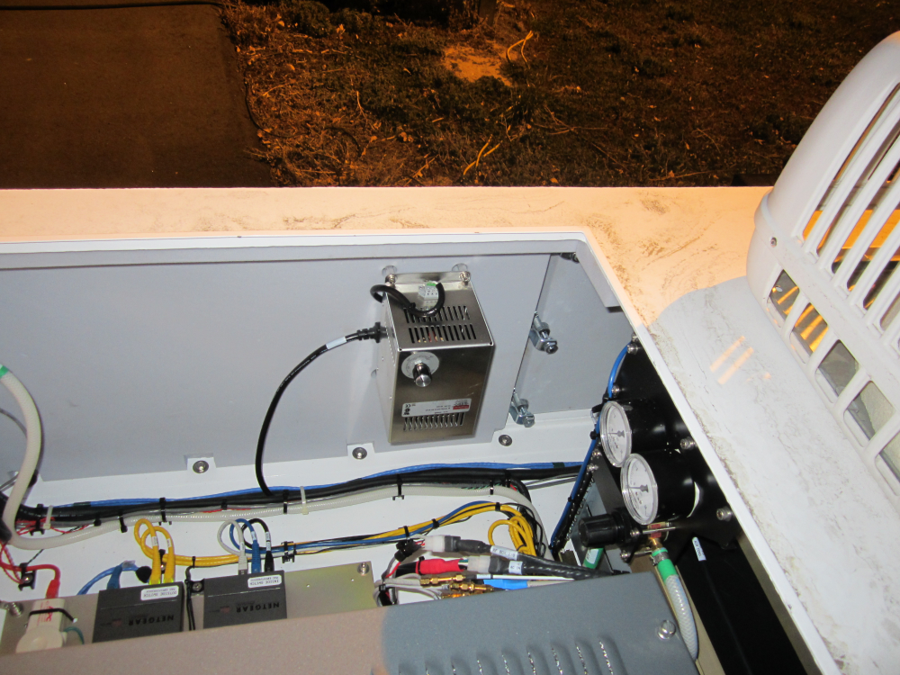

Heater

You turn the heater on using the X2/Y2 switches on the breaker, accessed from the side of the computer housing:



Heater switches

We left the heater set on a temperature that seemed reasonable so you should just be able to turn it on if needed. However, if you need to adjust the temperature you could slide your hand in and adjust the knob from here, but it’s probably better to access the heater in the same way you accessed the transmitter so you can see the settings on the knob. Remember to turn off the pedestal before accessing that area!